**Analysis of factors impacting**

**the HIE Implementation among US**

**mid-size and large hospitals**

# Harish Visweswaraiya

# Sanjeev Sukumaran

# Srinjoy Das

# Sucheta Kamalakar

# Vivek Varadarajan

# **Executive Summary**

**Background**: HIE is the electronic exchange of clinical information among healthcare information systems. The goal of HIE is to facilitate access to, and retrieval of , clinical data to provide safe, timely, efficient, effective, equitable and patient-centered care. HIE can be classified into two types - (1) HIE within hospital network (2) HIE outside hospital.

**Objective**: (1) To identify control factors and key factors that influence HIE implementation.

(2) Effect of these factors on:

(a) HIE with hospitals and ambulatory providers inside the network

(b) HIE with hospitals and ambulatory providers outside the network.

(c) Patient engagement with their hospital (access to their medical data online)

**Methods**: The data has been collected from AHA IT dataset which sent out a survey to 3283 hospitals across US. The survey included questions across a wide range of topics - HIT, Meaningful use, HIE, EHR attributes. Only hospitals with bed size above 100 were considered. A scoring system was developed for the identified independent and dependent variables. This score grouped relevant survey attributes and assigned weighted scores based on the extent of implementation. Analysis was then performed using factor analysis, PCA, ANOVA and linear regression techniques.

**Results**: The results indicate that the key factors influencing HIE implementation within network for mid-size hospitals are Result viewing features and decision support system features. Similarly, significant factors that influence the HIE implementation outside hospital system and patient engagement have been identified for mid-size and large hospitals.

**Detailed Report**

**Background**

HIE is the electronic exchange of clinical information among healthcare information systems. The goal of HIE is to facilitate access to, and retrieval of, clinical data to provide safe, timely, efficient, effective, equitable and patient-centered care.

Electronic health information exchange (HIE) allows doctors, nurses, pharmacists, other health care providers and patients to appropriately access and securely share a patient’s vital medical information electronically—improving the speed, quality, safety and cost of patient care.

As a part of this project, two aspects of HIE implementation have been considered:-

1) HIE with hospitals and ambulatory providers inside the network 2) HIE with hospitals and ambulatory providers outside the network.

There are numerous benefits of HIE implementation. The primary ones are - 1) improves Healthcare Quality 2) makes care more Efficient 3) Streamline Administrative Tasks 4) Support Community Health 5) Improve patient safety by reducing medication and medical errors 6) Increase efficiency by eliminating unnecessary paperwork and handling 7) Engage healthcare consumers regarding their own personal health information 8) Improve healthcare quality and outcomes 9) Reduces health related costs

The main challenges that healthcare organizations face in implementing HIE are :-

* Data sharing - Much of the information sharing happens in silos
* Patient consent - Patient authorization is necessary to share patient data with anyone. Patients are usually hesitant to share their health data as they consider it private.
* Standards - Different vendors have different standards which make information exchange a complex process
* Complexity costs - HIE systems are quite complex and hence are expensive too
* Competition - Competition among healthcare providers exists which slows down cooperation

The main objectives of this project are:-

(1)To identify control factors and key factors that influence HIE implementation.

(2) Effect of these factors on:

(a) HIE with hospitals and ambulatory providers inside the network

(b) HIE with hospitals and ambulatory providers outside the network.

(c) Patient engagement with their hospital (access to their medical data online)

# **Literature review**

|  |  |  |  |
| --- | --- | --- | --- |
| Source | Sample | Key Questions | Important Findings |
| Factors motivating and affecting health information exchange usage  <http://dx.doi.org/10.1136/jamia.2010.004812> | The study sample was drawn from all emergency department (ED) encounters among patients ages 18 to 64 that occurred between January 1, 2006 and June 30, 2009. We also excluded any emergency encounters occurring at facilities before the hospital had an authorized user of the I-Care system. The final dataset included 271 305 encounters (111 482 unique patients) from 10 facilities. | The aim of this study was to determine the factors associated with different types of HIE usage. | First, these results identify time constraints as a barrier to HIE usage. This simple finding, consistent with information-seeking theory and prior research, has immediate application to the design and function of HIE efforts |
| Overcoming challenges to achieving meaningful use: insights from hospitals that successfully received Centers for Medicare and Medicaid Services payments in 2011  http://dx.doi.org/10.1136/amiajnl-2012-001142 | The study sample consisted of 2475 hospitals, 313 of which received MU payments in 2011. Controlling for standard hospital characteristics, hospitals that reported the computerized provider order entry (CPOE) MU criterion as a primary challenge were 18% less likely to receive a 2011 MU payment compared to hospitals that reported other criteria as primary challenges. | To understand better the federal electronic health record (EHR) incentive program’s challenges | Bed Size :  1-125 , 126-399, >400  Relative to other EHR functions, there is more evidence of CPOE's value in terms of quality and safety improvements |
| Patient Experiences With Full Electronic Access to Health Records and Clinical Notes Through the My HealtheVet Personal Health Record Pilot: Qualitative Study  http://www.jmir.org/2013/3/e65/ | Recruitment letters were mailed to a random sample of 126 eligible patients; 45 patients and 2 family delegates responded, of which 40 expressed interested in the study. The principal investigator telephoned the 40 responders, providing more information about the study and inviting each to attend a focus group. A total of 30 patients and 6 family members attended a session. Groups averaged 7 participants. Patient age ranged from 49-82 years and 4 patients (11%) were women | Patient Experiences with Full Electronic Access to Health Records and Clinical Notes Through the My HealtheVet Personal Health Record Pilot: Qualitative Study | Perceived Enhanced Communication With Providers and Health Care Team  One benefit frequently described by patients was that access to health record information served to facilitate communication about their care. Patients reported better recall of appointments and care issues, felt more prepared for in-person visits, and found a greater ability to communicate with providers inside and outside the VA. |
| Meaningful Use of Electronic Health Records: Experiences From the Field and Future Opportunities  http://medinform.jmir.org/2015/3/e30/ | gency for Healthcare Research and Quality (AHRQ) (n=5), Kaiser Permanente (n=4), Brigham and Women’s Hospital (n=3), Cincinnati Children’s Hospital Medical Center (n=2), Food and Drug Administration (FDA) (n=2), Duke University (n=3), Rutgers University (n=2), University of Alabama at Birmingham (n=2), Intermountain Healthcare (n=1), University of Illinois at Chicago (n=1), Northwestern University (n=1), University of Washington (n=1), University of Maryland (n=1), Baylor Scott and White Health (n=1), Baylor College of Medicine (n=1), Blue Cross Blue Shield Association (n=1), and a variety of others (n=4) | With the aim of improving health care processes through health information technology (HIT), the US government has promulgated requirements for “meaningful use” (MU) of electronic health records (EHRs) as a condition for providers receiving financial incentives for the adoption and use of these systems | Definitions of transitions in care should enable and support shared patient record systems. Better tools and interoperability with external data are needed for effective and efficient medication reconciliation. On the other hand, measures should not drive unnecessary or unreliable data transmission.  Future MU requirements should put more emphasis on flexibly understanding, incorporating, and supporting local HIT configurations that address population health needs |
| The Effect of Health Information Technology on Health Care Provider Communication: A Mixed-Method Protocol  http://www.researchprotocols.org/2015/2/e72/ | This 4-year study uses a sequential mixed-methods design, beginning with a quantitative survey followed by a two-part qualitative phase. Survey results from aim 1 will provide a detailed assessment of health information and communication technologies in use and help identify sites with variation in health information and communication technologies for the qualitative phase of the study. In aim 2, we will conduct telephone interviews with hospital personnel in up to 8 hospitals to gather in-depth information about communication practices and work relationships on medical-surgical units. In aim 3, we will collect data in 4 hospitals (selected from telephone interview results) via observation, shadowing, focus groups, and artifacts to learn how health information and communication technologies, communication practices, and work relationships affect communication. | 1) identify the range of health information and communication technologies used in a national sample of medical-surgical acute care units,  (2) describe communication practices and work relationships that may be influenced by health information and communication technologies in these same settings, and  (3) explore how differences in health information and communication technologies, communication practices, and work relationships between physicians and nurses influence communication. | A related challenge will be to get physicians and nurses to participate in observation and shadowing |
| Patients Know Best: Qualitative Study on How Families Use Patient-Controlled Personal Health Records  http://www.jmir.org/2016/2/e43/ | The data gathering comprised a total of 23 hours of observations and approximately 9 hours of interviews. Interviews took between 7 and 45 minutes (with an average of 23 minutes). | This study set out to investigate patient families’ lived experiences of working with a PCEHR.  (patient-controlled electronic health records) | The focus of this study has been on PCEHRs(patient-controlled electronic health records), which can increase motivation to take responsibility in health management, potentially allowing people to better understand causal relations between treatments, other actions, and outcomes, and to identify opportunities for improvement. |
| Barriers Over Time to Full Implementation of Health Information Exchange in the United States  http://medinform.jmir.org/2014/2/e26/ | The 28 articles identified 16 barriers. |  | The concern of cost is discussed consistently in the literature  The second most consistent barriers discussed were efficiency/workflow, impedes competition, and value difficult to measure. |
| The Invisible Work of Personal Health Information Management Among People With Multiple Chronic Conditions: Qualitative Interview Study Among Patients and Providers  **http://www.jmir.org/2015/6/e137/** | A total of 22 patients and 7 providers were interviewed; patients had an average of 3.5 (SD 1.5) chronic conditions and reported having regular relationships with an average of 5 providers | A critical problem for patients with chronic conditions who see multiple health care providers is incomplete or inaccurate information, which can contribute to lack of care coordination, low quality of care, and medical errors. | Patients with multiple chronic conditions maintain relationships with multiple health care providers, usually spanning several medical institutions. Providers, and many patients, recognize the need for easy information flow across these medical settings  HIE Outside is important for patients with Chronic diseases |
| The Role of Health Care Experience and Consumer Information Efficacy in Shaping Privacy and Security Perceptions of Medical Records: National Consumer Survey Results  http://medinform.jmir.org/2015/2/e14/ | The data presented here are from the 2011-2012 administration of the NCI Health Information National Trends Survey (HINTS). HINTS is a nationally representative survey of the US noninstitutionalized adult population (≥18 years) that tracks attitudes, knowledge, and behavior related to health and cancer communication and health outcomes, with an emphasis on the evolution of health information technology in health care  Data collection for the fourth iteration of HINTS (HINTS 4 Cycle 1) began in October 2011 and concluded in February of 2012 (N=3959) | The aim of this study was to describe national perceptions regarding the privacy and security of medical records and identify a comprehensive set of factors associated with these perceptions. | As EHR adoption has increased dramatically, a majority of individuals report they are confident in the privacy and security of their medical records. |
| Physicians' opinions of a health information exchange  http://jamia.oxfordjournals.org/content/18/1/60 | A total of 29 clinicians participated in the study. The attendance rate was 66% (N=19) for the first and last month of focus-group meetings and 52% (N=15) for the focus group meetings conducted during the second month. | To evaluate physicians' perceptions regarding AMIE's impact on health outcomes and healthcare costs. | A survey of 216 ED clinicians found that 85% of respondents perceived that it is difficult or very difficult to obtain relevant outside clinical information at the point of care, and 97% expressed that HIE would benefit the delivery of clinical care. In addition, 88% of respondents perceived that HIE would increase the efficiency of clinical care, and 78% thought HIE would decrease the number of tests ordered |

**Methods:**

**Variable reduction techniques:**

Factor Analysis was performed on the 10 Challenge attributes. On the basis of factor analysis output the challenge attributes are reduced to 4 variables.

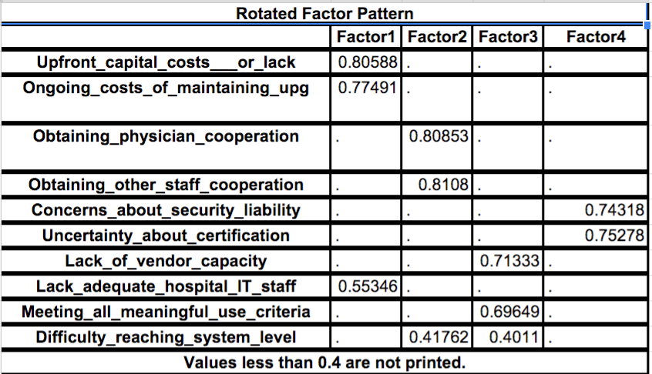

A Shapiro test was performed to determine whether the dependent variables “HIE inside hospital network” and “HIE outside hospital network” can be merged together into a single dependent variable. But the test failed, hence both “HIE inside hospital network” and “HIE outside hospital network” attributes were considered as dependent variable along with Patient Engagement attribute.

**Regressions**

A total of 9 linear regressions were performed on our data set.

3 Linear regressions was run on the entire dataset

- Linear Regression of dependent variable- Patient Engagement with all other independent variables

- Linear Regression of dependent variable- HIE Inside hospital network with all other independent variables

- Linear Regression of dependent variable- HIE Outside hospital network with all other independent variables

There were significance differences between the two bed size categories. Hence we further analyzed the sub samples as per hospital categorization.

A sub sample analysis was performed on the bed categories:

1. Medium Sized Hospitals (100<No of Beds<400)

- Linear Regression of dependent variable- Patient Engagement with all other independent variables

- Linear Regression of dependent variable- HIE Inside hospital network with all other independent variables

- Linear Regression of dependent variable- HIE Outside hospital network with all other independent variables

2. Large Sized Hospitals (No of Beds>400)

- Linear Regression of dependent variable- Patient Engagement with all other independent variables

- Linear Regression of dependent variable- HIE Inside hospital network with all other independent variables

- Linear Regression of dependent variable- HIE Outside hospital network with all other independent variables

**Dataset**

American Hospital Association (AHA) is an organization that promotes the quality provision of health care by hospitals and health care networks. AHA conducted a survey of hospitals across United States with 18 questions with the aim to serve as an instrument that can be used to facilitate sales, planning and marketing activities of the implementation of electronic healthcare system.

The survey included questions across a wide range of topics – Health Information Technology (HIT), Meaningful Use, Health Information Exchange (HIE), Electronic Health Record (EHR) attributes. The survey data of around 3283 hospitals who responded to the survey was considered for our analysis. Hence our dataset consisted of 3283 rows and 171 attributes which covered all the options of the 18 questions asked in the survey

Out of the 3283 records, only the hospitals with number of beds > 100 were considered for our analysis. The dataset consisted of both Categorical and Numerical variables.

There are two control factors:

1. Hospital Classification on ownership type- Government, Non-Government, Investor-owned

2. Hospital Care type- General, Specialty

The data set was also categorized on the basis of the number of beds:

1. 400>No of Beds>100 – Medium Sized Hospitals

2. No of Beds >400 – Large Sized Hospitals

**Data Manipulation:**

**Independent Variables:**

**Data scoring process -** Relevant survey attributes were grouped and assigned weighted scores based on the extent of implementation. No-responses are left blank and were handled by R during the analysis.

The main parameters considered for dependent variables are - Electronic Clinical documentation, Results viewing, Computerized Provider Order Entry, and Decision Support.

The full implementation of these factors in all units, at least one unit, beginning of implementation in at least one unit was considered in giving proportional weightage to scores. If the hospital had indicated that they have resources to implement in next year or that they do not have resources but are considering implementing, these were not considered for scoring. The scores for each factors were given as shown in the below table. As seen, the total score for ECD was between 0 and 42, score for results viewing between 0 and 36, score for CPOE was between 0 and 30, and score for decision support between 0 and 36.

|  |  |  |  |  |  |
| --- | --- | --- | --- | --- | --- |
| **Parameters** |  | Fully  Implemented  Across ALL  Units | Fully  Implemented  in at least  one Unit | Beginning  to Implement  in at least  one Unit | Score range |
| Electronic Clinical documentation | Patient demographics | 3 or 0 | 2 or 0 | 1 or 0 | 0-6 |
| Physician notes | 3 or 0 | 2 or 0 | 1 or 0 | 0-6 |
| Nursing notes | 3 or 0 | 2 or 0 | 1 or 0 | 0-6 |
| Problem lists | 3 or 0 | 2 or 0 | 1 or 0 | 0-6 |
| Medication lists | 3 or 0 | 2 or 0 | 1 or 0 | 0-6 |
| Discharge summaries | 3 or 0 | 2 or 0 | 1 or 0 | 0-6 |
| Advanced directives | 3 or 0 | 2 or 0 | 1 or 0 | 0-6 |
| Total ECD score |  |  |  |  | 0-42 |
| Results Viewing | Laboratory reports | 3 or 0 | 2 or 0 | 1 or 0 | 0-6 |
| Radiology reports | 3 or 0 | 2 or 0 | 1 or 0 | 0-6 |
| Radiology images | 3 or 0 | 2 or 0 | 1 or 0 | 0-6 |
| Diagnostic test results | 3 or 0 | 2 or 0 | 1 or 0 | 0-6 |
| Diagnostic test images | 3 or 0 | 2 or 0 | 1 or 0 | 0-6 |
| Consultant reports | 3 or 0 | 2 or 0 | 1 or 0 | 0-6 |
| Total Results viewing score |  |  |  | 0-36 |
| Computerized Provider Order Entry | Laboratory tests | 3 or 0 | 2 or 0 | 1 or 0 | 0-6 |
| Radiology tests | 3 or 0 | 2 or 0 | 1 or 0 | 0-6 |
| Medications | 3 or 0 | 2 or 0 | 1 or 0 | 0-6 |
| Consultation requests | 3 or 0 | 2 or 0 | 1 or 0 | 0-6 |
| Nursing orders | 3 or 0 | 2 or 0 | 1 or 0 | 0-6 |
| Total CPOE score |  |  |  |  | 0-30 |
| Decision support | Clinical guidelines | 3 or 0 | 2 or 0 | 1 or 0 | 0-6 |
| Clinical reminders | 3 or 0 | 2 or 0 | 1 or 0 | 0-6 |
| Drug allergy alerts | 3 or 0 | 2 or 0 | 1 or 0 | 0-6 |
| Drug-drug interaction alerts | 3 or 0 | 2 or 0 | 1 or 0 | 0-6 |
| Drug-lab interaction alerts | 3 or 0 | 2 or 0 | 1 or 0 | 0-6 |
| Drug dosing support | 3 or 0 | 2 or 0 | 1 or 0 | 0-6 |
| Total decision support |  |  |  |  | 0-36 |

The challenges listed in the survey were -

1) Upfront capital costs/lack of access to capital to install systems

2) Ongoing cost of maintaining and upgrading systems

3) Obtaining physician cooperation

4) Obtaining other staff cooperation

5) Concerns about security or liability for privacy breaches

6) Uncertainty about certification requirements

7) Limited vendor capacity

8) Lack of adequate IT personnel in hospital to support implementation/maintenance

9) Challenge/complexity of meeting all meaningful use criteria within implementation timeframe

10) Complexity associated with coordinating decision with system-level leadership

Factor Analysis was performed to scale down the 10 challenge variables to 4 variables as shown in the below table -

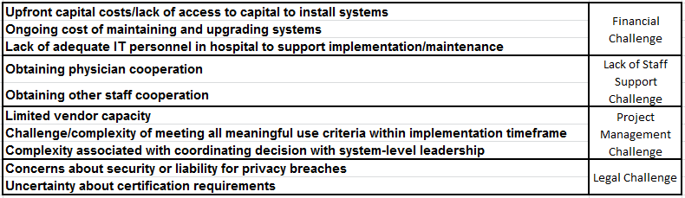

These challenges were then scored based on PCA (Principal Component analysis) scores. PCA is a statistical procedure that uses an [orthogonal transformation](https://en.wikipedia.org/wiki/Orthogonal_transformation) to convert a set of observations of possibly correlated variables into a set of values of [linearly uncorrelated](https://en.wikipedia.org/wiki/Correlation_and_dependence) variables called principal components. The number of principal components is less than or equal to the number of original variables.

Identified Independent Variables:

1) Number Of Years 2) Results View Score 3) Decision Support Score 4) Computerized Physician Order Entry Score 5) Electronic Clinical Documentation Score 6) Legal Challenge 7) Project Management Challenge 8) Lack of Staff Support Challenge 9) Financial Challenge

**Dependent Variables:**

**Data scoring process- Relevant survey attribute were grouped and assigned similar scores. No responses were left blank and were handled by R during analysis.**

The dependent variable HIE within network was scored on the basis of whether the particular health information like laboratory results, etc. was exchanged with hospitals and ambulatory providers in the system. The score was between 0 and 12 based on these parameters.

|  |  |  |  |  |
| --- | --- | --- | --- | --- |
|  |  | With Hospitals in system | With ambulatory providers in system | Score range |
| **HIE within network** | Patient demographics | 1 or 0 | 1 or 0 | 0-2 |
| Laboratory results | 1 or 0 | 1 or 0 | 0-2 |
| Medication history | 1 or 0 | 1 or 0 | 0-2 |
| Radiology reports | 1 or 0 | 1 or 0 | 0-2 |
| Clinical/Summary care record in any format | 1 or 0 | 1 or 0 | 0-2 |
| Other types of patient data | 1 or 0 | 1 or 0 | 0-2 |
| **Total HIE within network score** |  |  |  | 0-12 |

The dependent variable HIE outside network was scored on the basis of whether the particular health information like laboratory results, etc. was exchanged with hospitals and ambulatory providers outside the system. The score was between 0 and 12 based on these parameters.

|  |  |  |  |  |
| --- | --- | --- | --- | --- |
|  |  | With Hospitals outside system | With ambulatory providers outside system | Score range |
| **HIE outside network** | Patient demographics | 1 or 0 | 1 or 0 | 0-2 |
| Laboratory results | 1 or 0 | 1 or 0 | 0-2 |
| Medication history | 1 or 0 | 1 or 0 | 0-2 |
| Radiology reports | 1 or 0 | 1 or 0 | 0-2 |
| Clinical/Summary care record in any format | 1 or 0 | 1 or 0 | 0-2 |
| Other types of patient data | 1 or 0 | 1 or 0 | 0-2 |
| **Total HIE outside network score** |  |  |  | 0-12 |

The third dependent variable Patient Engagement was scored based on the patient’s ability to do the following -

1) View information from their health/medical record online

2) Download information from their health/medical record

3) Electronically transmit (send) transmission of care/referral summaries to a third party

4) Request an amendment to change/update their health/medical record

5) Request refills for prescriptions online

6) Schedule appointments online

7) Pay bills online

8) Submit patient-generated data (e.g., blood glucose, weight)

Each parameter above which the hospital said ‘yes’ to, was scored one. This created a score for each hospital in the range of 0 to 8.

Shapiro test was done to determine the number of Dependent variable to be considered for the analysis.

Identified Dependent Variables:

1) Health Information Exchange (HIE) within hospital system 2) Health Information Exchange (HIE) outside hospital system

## 

## **Sample Demographics:**

The final dataset consisted of dependent variables, independent variables and control factors. To follow is the statistical analysis of every variable.

**Independent Variables:**

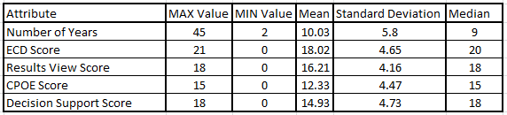

**Dependent Variables:**

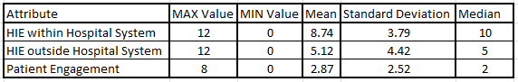

**Control Variable**

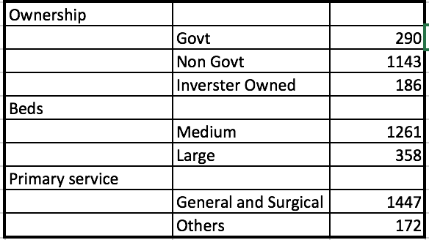

|  |  |  |  |  |  |
| --- | --- | --- | --- | --- | --- |
|  |  |  |  |  |  |
|  |  |  |  |  |  |
|  |  |  |  |  |  |
|  |  |  |  |  |  |
|  |  |  |  |  |  |
|  |  |  |  |  |  |

**Analysis and Results**

Patient Engagement

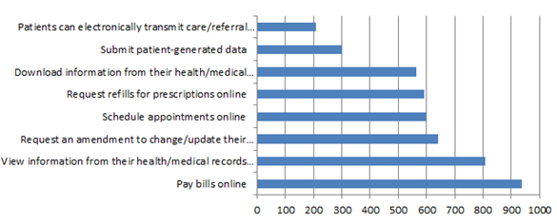

The above graph describes the number of hospitals which have said that the patients can access each of the above information. For example, The number of hospitals where the patients can electronically transmit care/referral information is around 300. The graph indicates that paying bills online is the most common online activity that patients can perform in these hospitals.

HIE within network

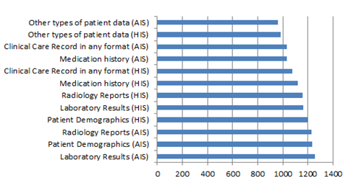

The above graph indicates how many hospitals exchange each kind of information with hospitals and ambulatory providers inside the network. For example, 1200 hospitals exchange Patient demographics with hospitals and ambulatory providers within the system. The graph indicates that Laboratory results are the most commonly exchange information by hospitals within network.

HIE Outside network

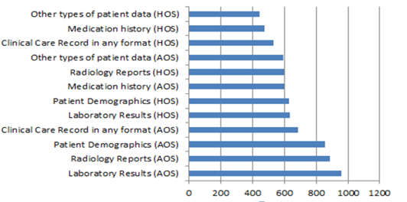

The above graph indicates how many hospitals exchange each kind of information with hospitals and ambulatory providers outside the network. For example, 600 hospitals exchange Radiology reports with hospitals and ambulatory providers outside system. The graph indicates that Laboratory results are the most commonly exchange information by hospitals outside network.

ANOVA

|  |  |  |  |
| --- | --- | --- | --- |
| Anova Results | | | |
|  | **HIE within system** | **HIE outside system** | **Patient Engagement** |
| Beds | 2.57e-09 *** | 1.75e-06 *** | 1.94e-09 *** |
| Ownership | 2e-16 *** | 2e-16 *** | 2e-16 *** |
| Service type | 6.35e-15 *** | 2.8e-07 *** | 6.15e-12 *** |

**Table** :Anova results(shown are P values)

**Signif. codes**: 0 |‘***’ 0.001 |‘**’ 0.01 |‘*’ 0.05 |‘.’ 0.1| ‘ ’ 1

As we can see from the anova results, for:

**HIE within the system**

Considering the **bed size** categories, Medium(100-399) & Large(400+) , we notice that the two groups are significantly different as we reject null hypothesis with 99.99% Confidence. So, we decided to form sub samples based on bed size.

Considering the **Ownership categories,** investor owned, Non government owned and government owned hospitals, we notice that the two groups are significantly different as we reject null hypothesis with 99.99% confidence. So we decided to form dummy independent variables, for further regression analysis.

Considering the **Service type,** General medical service and other service types(Psychiatry and specialty), we notice that the two groups are significantly different as we reject null hypothesis with 99.99% confidence. So we decided to form dummy independent variables, for further regression analysis.

**HIE outside the system**

Considering the **bed size** categories, Medium(100-399) & Large(400+) , we notice that the two groups are significantly different as we reject null hypothesis with 99.99% Confidence. So, we decided to form sub samples based on bed size.

Considering the **Ownership categories,** investor owned, Non government owned and government owned hospitals, we notice that the two groups are significantly different as we reject null hypothesis with 99.99% confidence. So we decided to form dummy independent variables, for further regression analysis.

Considering the **Service type,** General medical service and other service types(Psychiatry and specialty), we notice that the two groups are significantly different as we reject null hypothesis with 99.99% confidence. So we decided to form dummy independent variables, for further regression analysis.

**Patient Engagement**

Considering the **bed size** categories, Medium(100-399) & Large(400+) , we notice that the two groups are significantly different as we reject null hypothesis with 99.99% Confidence. So, we decided to form sub samples based on bed size.

Considering the **Ownership categories,** investor owned, Non government owned and government owned hospitals, we notice that the two groups are significantly different as we reject null hypothesis with 99.99% confidence. So we decided to form dummy independent variables, for further regression analysis.

Considering the **Service type,** General medical service and other service types(Psychiatry and specialty), we notice that the two groups are significantly different as we reject null hypothesis with 99.99% confidence. So we decided to form dummy independent variables, for further regression analysis.

**Regression**



TABLE: Regression Results

|  |  |
| --- | --- |
| Legends |  |
|  | 99.99% |
|  | 99% |
|  | 95% |

From the table output shown above, we can interpret the R-output results with the order of significance. ***- represents 99.99% confidence of interpretation of test of significance between dependent and independent variables.

**HIE within the system:**

For mid-size hospitals, as we can see, Investor owned, result view and decision support system are the most significant factors that influence the HIE implementation within hospital system.

For large hospitals, Investor owned is the most significant factor that influence the HIE implementation within hospital system.

**HIE outside the system:**

For mid-size hospitals, as we can see, Investor owned, result view and decision support system are the most significant factors that influence the HIE implementation outside hospital system.

For large hospitals, Government owned and legal challenges are the most significant factor that influence the HIE implementation outside hospital system.

**HIE Patient Engagement:**

For mid-size hospitals, as we can see, Investor owned, financial challenges and decision support system are the most significant factors that influence the HIE patient engagement.

For large hospitals, Investor owned and decision support are the most significant factor that influence the HIE Patient Engagement.

**Findings and Conclusions**

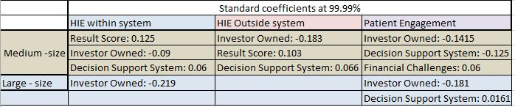

We interpret the influence of significant factors on extent of HIE implementation based on standard coefficient results from linear regression. The table above displays the standard coefficient values obtained at 99.99% confidence.

**For example:**

In case of HIE within system in mid size hospitals, every unit increase in result viewing will explain the increase the HIE score by 12.5%.

Similarly in case of HIE patient engagement for mid sized hospitals, every unit increase in decision support system will decrease the HIE score by 12.5%

REFERENCES:

1.Factors motivating and affecting health information exchange usage

<http://dx.doi.org/10.1136/jamia.2010.004812>

2.Overcoming challenges to achieving meaningful use: insights from hospitals that successfully received Centers for Medicare and Medicaid Services payments in 2011

http://dx.doi.org/10.1136/amiajnl-2012-001142

3.Patient Experiences With Full Electronic Access to Health Records and Clinical Notes Through the My HealtheVet Personal Health Record Pilot: Qualitative Study

http://www.jmir.org/2013/3/e65/

4.Meaningful Use of Electronic Health Records: Experiences From the Field and Future Opportunities

<http://medinform.jmir.org/2015/3/e30/>

5.The Effect of Health Information Technology on Health Care Provider Communication: A Mixed-Method Protocol

<http://www.researchprotocols.org/2015/2/e72/>

6.Patients Know Best: Qualitative Study on How Families Use Patient-Controlled Personal Health Records

http://www.jmir.org/2016/2/e43/

7.Barriers Over Time to Full Implementation of Health Information Exchange in the United States

<http://medinform.jmir.org/2014/2/e26/>

8.The Invisible Work of Personal Health Information Management Among People With Multiple Chronic Conditions: Qualitative Interview Study Among Patients and Providers

http://www.jmir.org/2015/6/e137/

9.The Role of Health Care Experience and Consumer Information Efficacy in Shaping Privacy and Security Perceptions of Medical Records: National Consumer Survey Results

http://medinform.jmir.org/2015/2/e14/

10.Physicians' opinions of a health information exchange

<http://jamia.oxfordjournals.org/content/18/1/60>

11 AHA Home Page .http://www.aha.org/

12. <https://www.healthit.gov/providers-professionals/health-information-exchange/what-hie>

<http://www.govhealthit.com/news/top-5-roadblocks-hies-face>